Primary 1/2 Term 1 Newsletter
Dear Parents and Carers,
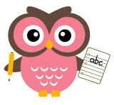
Welcome everyone to a new term. Our 16 primary one pupils have all settled into school and are learning new classroom routines with the help of our 8 primary two girls. We have a busy time ahead, our topic for this term being ‘People Who Help Us’. We will be learning about the different roles people play in our community and ways in which we keep safe. If any parent has an interesting job linked to our topic and would be willing to come in and talk to the class then please do get in touch.

Term 1 Weekly Timetable

Monday | French: Madame Canessa  Library
Tuesday | Art: Mrs Robertson  P.E: Mrs McTaggart
Wednesday | Circle Time  Outdoor run  Paired Reading
Thursday | P.E: Mr Witt  ERIC Time  Activities
Friday | Outdoor run  Assembly  Golden time

It is useful to have a P.E kit in school all week in case it is needed at other times. Please ensure that P.E. kits and other items of clothing and belongings such and pencil cases etc. are clearly named. Also, just a reminder that water bottles should only contain water and not juice.
Homework
Primary One: Maths homework will usually be issued on a Monday for completion by Friday. Phonics homework (blue jotter) comes home twice a week and this is linked to the new letter sounds taught. Monday homework should be returned by Wednesday and Thursday homework should be returned by Monday.
Primary Two: Spelling and Maths homework will usually be sent out on a Monday to be completed by Friday. Reading comprehension tasks may be issued along with reading homework so do please check homework bags each day.
We ask that parents/carers sign or initial the homework to acknowledge that you have seen it.

Literacy
Our Primary Ones have been sharing their Summer Bags with the rest of the class. They are a great way to help your child to remember all of the fun activities they got up to over the summer, so thank you for sending them in. The bags are now on display in our classroom.
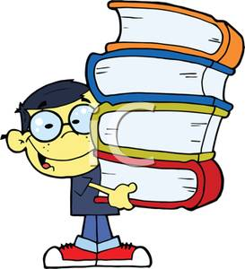
Active Literacy takes place daily. Primary ones will learn two letter sounds each week and begin to blend the sounds together to make words. Primary twos will revise diagraphs (together sounds) as well as blending to read and write words and sentences themselves. Each child should now have a "Word Wallet". Try to practise reading the words as often as you can.

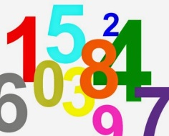
Numeracy This term we will be learning about 2D and 3D shapes. We will explore different ways of finding and displaying information. Primary one will practise counting and correct number formation up to 10. Primary two will practise subtraction and numbers beyond 20.

Library This term we will be visiting the school library on a Monday. Please remember to return your book each week so that you can borrow a new one.

Events this term
- The Primary One Curriculum Evening is on Monday the 11th September at 6:15pm in the P1/2 classroom.
- Parent/Teacher consultations will take place on the 3rd and 4th of October.
- Our class Sharing Assembly is on Friday 13th October at 2pm in the school hall.

If you have any questions or wish to discuss anything, you are welcome to pop in after school or ring the office to make an appointment. Alternatively, you can contact me directly via class dojo messages during school hours.

Thank you for your support
Mrs Susan McTaggart (P1/2 Class Teacher)

